RESOLUTION NO.__________

RE: CERTIFICATE OF APPROPRIATENESS UNDER THE
PROVISIONS OF THE ACT OF THE PENNSYLVANIA
LEGISLATURE 1961, JUNE 13, P.L. 282 (53
SECTION 8004) AND BETHLEHEM ORDINANCE NO.
3952 AS AMENDED.

WHEREAS, it is proposed to install install window signs at 17 East 3rd Street.

NOW, THEREFORE, BE IT RESOLVED by the Council of the City of Bethlehem that a Certificate of Appropriateness is hereby granted for the work.

Sponsored by: (s)

(s)

ADOPTED BY COUNCIL THIS DAY OF

(s)
President of Council

ATTEST:

(s)
City Clerk

HISTORIC CONSERVATION COMMISSION

CASE # 481 – It is proposed to install install window signs at 17 E 3rd Street.
OWNER/APPLICANT: Charles Buck / Franklin Pichardo

The Commission upon motion by Mr. Lader seconded by Mr. Cornish adopted the proposal that City Council issue a Certificate of Appropriateness for the proposed work described herein:
- The proposal to install install window signs at 17 E 3rd Street was presented by Franklin Pichardo.
- The sign proposed for the front right side display window will be installed as a projecting sign on the existing sign bracket as discussed at the meeting. On the display window will be a sign, in white only, reading TO’MAKAO, Fine Cigars, Hand Made.
- The sign on the door will be as proposed and will read “TO’MAKAO”, “Fine Cigars” in white.
- The sign on the left display window will read “CIGARS” in a vertical format, as proposed, but must be reduced in size.
- The address of the store will be placed in small white letters at the bottom of the curved glass of the left display window, and the store hours will be placed in small white lettering at the bottom of the flat angled glass of the right display window.
- Scaled drawings for the projecting sign and the reduced vertical “CIGARS” sign need to be submitted before installation.
- The proposed motion was unanimously approved.

CU: cu

By: 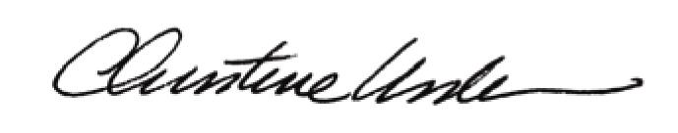

Date of Meeting: December 16, 2013 Title: Historic Officer

